

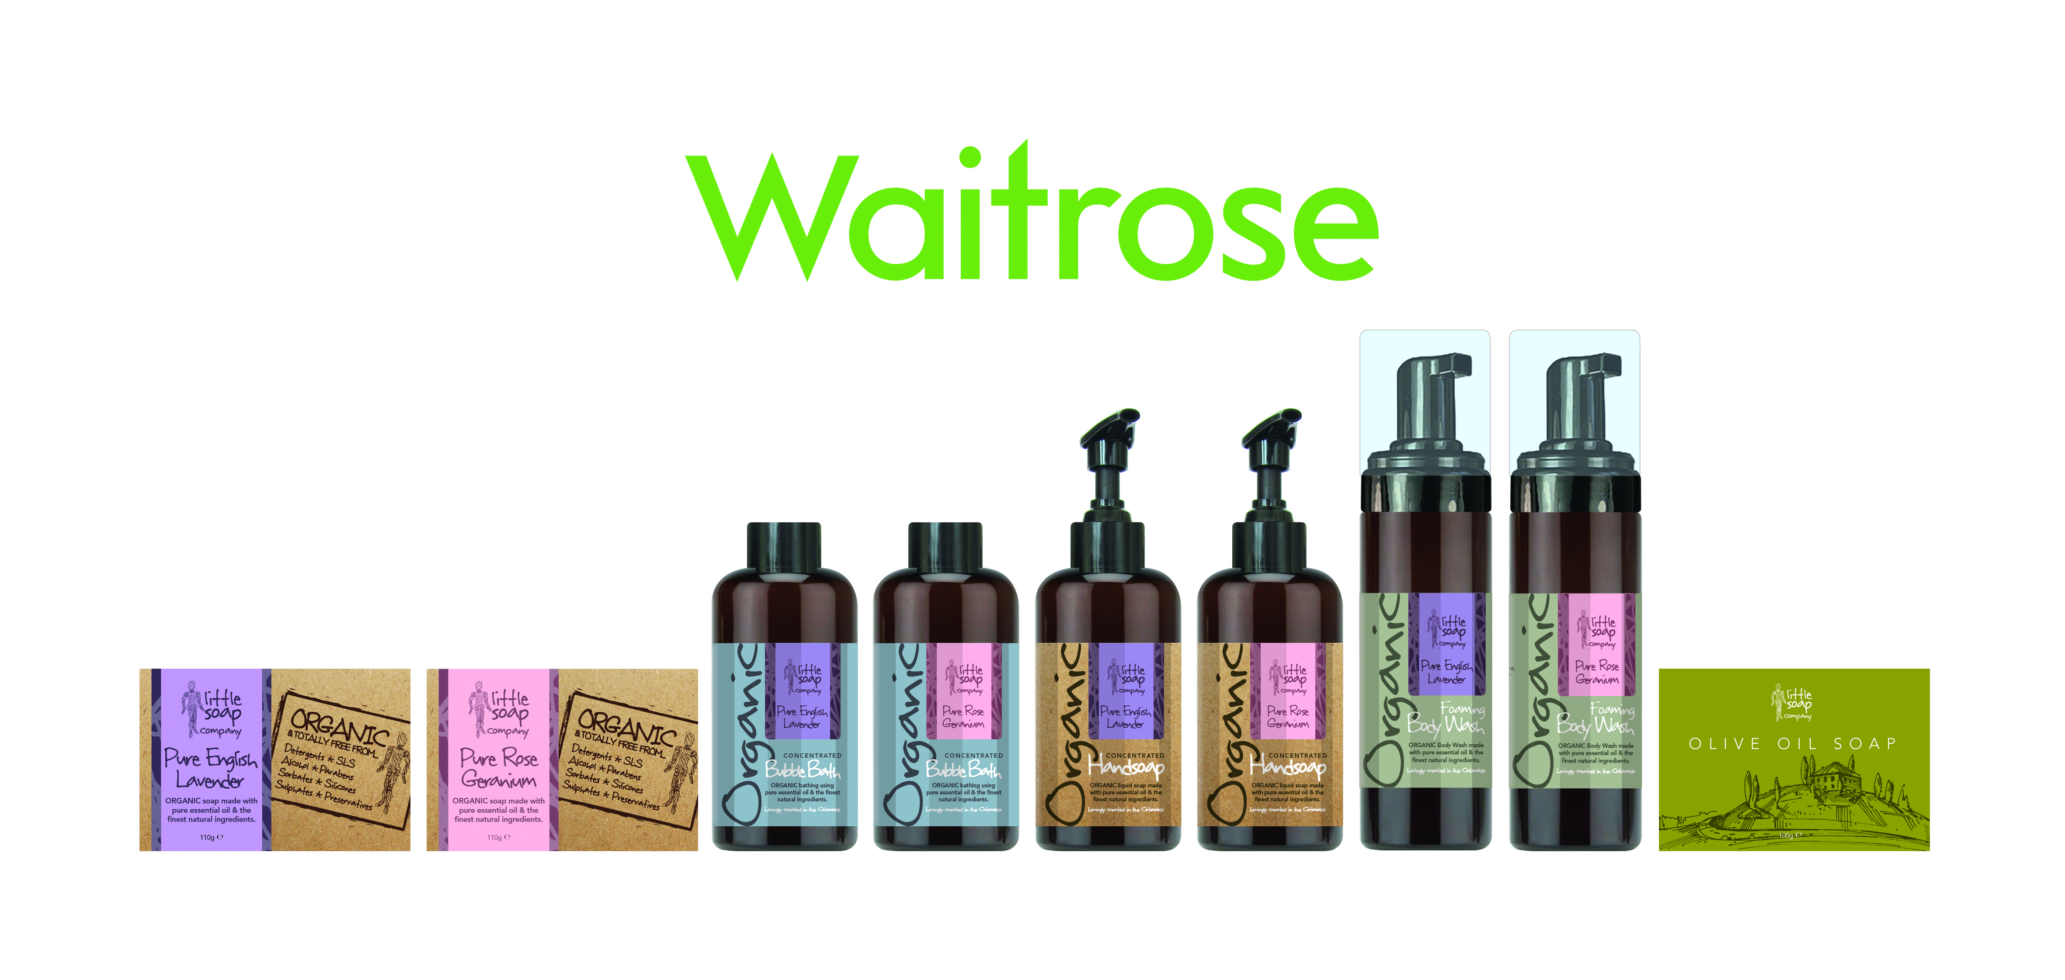

*Little Soap Company* was conceived by Emma Heathcote-James. Originally an insatiable one-woman band passionate about reducing the amount of chemicals and synthetics people unwittingly rub into their skin the business has significantly grown. Wanting to do for the cosmetics industry what Jamie Oliver has done for food, Emma wanted to get the world back to basics, creating the purist organic soap she believes possible and making it accessible to everyone.

From hand-making soap on the kitchen table and selling in subzero temperatures at farmers markets, the company started to meet its aim, as within six months it was lining the shelves of 8 local Waitrose stores in 2009 and the company deemed one of Waitrose ‘local heroes’. The Little Soap Company then launched regional into 45 Tesco stores and nationally in to all Waitrose stores in 2013 with bar soap (their best beauty launch and fastest selling bar soap and indeed first organic soap to hit the shelves…). From here the soaps have rolled out nationally across Boots, Booths, Sainsbury and Tesco to name but a few…

The range has grown to the current exclusive 10 lines of organic bars, liquid hand soap, foaming body wash and bubble bath which launched last year.

**LATEST AWARDS (see products in online shop for all awards)**

* Finalist in the Inflexion Entrepreneur of the Year Category for the **National Business Awards** – results in November
* ***Rose Geranium Organic Bubble Bath*** won Janey Lee Grace Platinum Beauty Awards BEST NEWCOMER 2016
* ***Rose Geranium Liquid Handsoap*** is WON Silver for the FREE FROM SKIN CARE AWARD
* ***Rose Geranium Bar Soap*** won a Bronze Green Parent Award (nb this result is embargoed until July 1st ) – plus other industry awards all on the products in the online shop…
* Emma was Finalist for the ***Worcestershire Woman of the Year*** in 2014
* Emma won Hereford & Worcestershire Chamber of Commerce ***Entrepreneur of the Year*  2015-16** and has collected numerous other industry awards along the way (see website) for her increasing range of products.
* Emma has been nominated for the Lloyds Business Awards November 2016 in the Entrepreneur category.

**ABOUT US:** Little Soap Company was founded by Emma Heathcote-James. Emma’s aim was to create a natural, organic, and sustainable soap which she could sell locally. Then she had bigger ambitions. It had always bothered Emma why the supermarkets didn’t offer more choice, in fact in some cases ANY choice of pure, natural and organic soap on their shelves.

**WHAT MAKES US UNIQUE?** This is the first English soap bar and liquid to hit supermarket shelves which is pure organic, fragranced only with essential oils and most importantly is affordable.